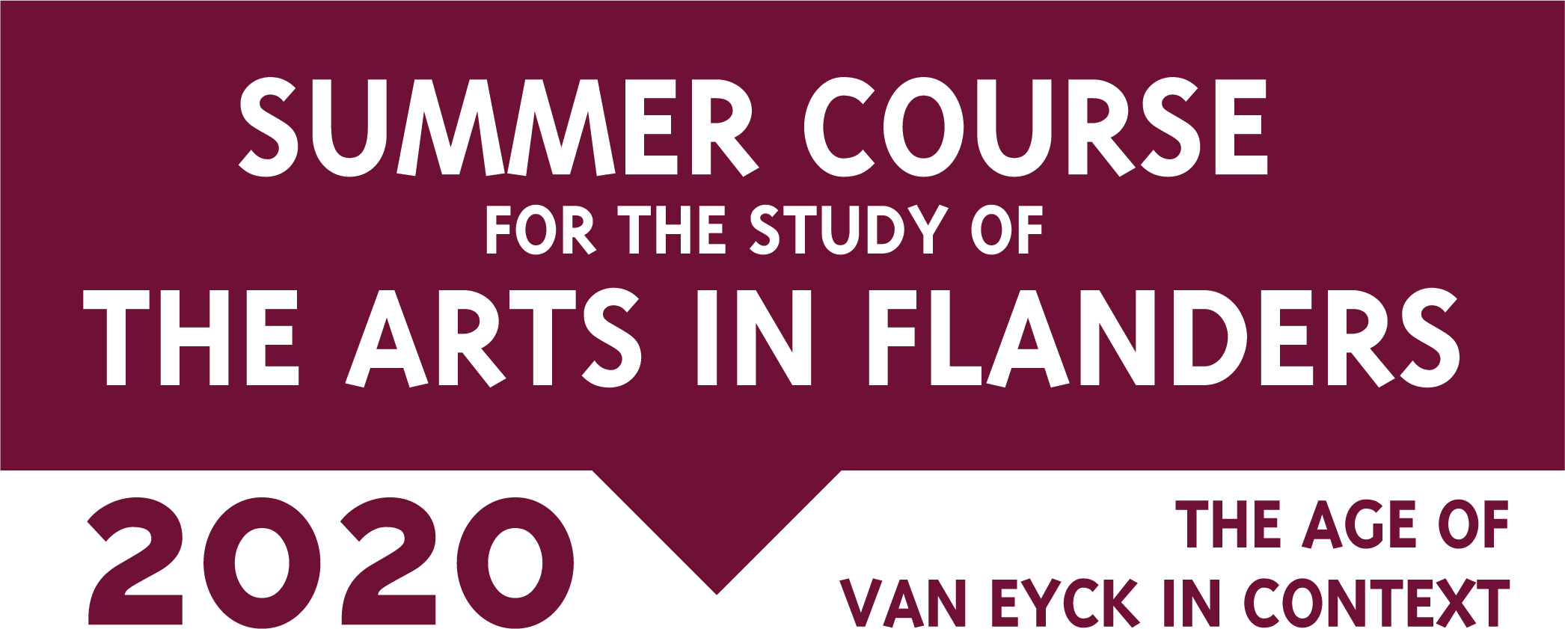
Application form
Grant Summer Course for the Study of the Arts in Flanders
The Age of Van Eyck in context, June 21 – July 1, 2020
To facilitate students with limited financial means, the organisation of the Summer Course for the Study of the Arts in Flanders has made available two grants of €544,5 each. These grants will be awarded (preferably) to one European and one non-European applicant of the Summer Course. The recipients of the grant will pay a reduced participation fee of €544,5 instead of the regular fee of €1089. To apply for one of these grants, please fill in the form below and send it, together with a resume, a letter of motivation and a letter of recommendation from a faculty member or a museum professional to an.seurinck@vlaamsekunstcollectie.be before December 15, 2019, 5 p.m (CET).
The recipients of the grants will be notified in January 2020.
All information received will be treated confidentially.
Form
Name
First name
Date of birth (day/month/year)
M/F/X
Citizenship
Home address
Email address
Phone number
University / Institution
Address of institution
Contact person (person who writes recommendation) and contact details (phone number and email address)

Other grants applied to, related to participation in Summer Course (please specify amount as well):
…..
…..
Grants received, related to participation in Summer Course (please specify amount as well):
…..
…..
Previous grants received based on financial need (please specify amount as well):
…..
…..
Grant motivation:
…..
…..

